**Second Progress Report**

On

**Dynamic routing**

Submitted in partial fulfillment of the requirements for the award of degree of

**BACHELOR OF ENGINEERING**

**IN**

**COMPUTER SCIENCE & ENGINEERING**



**Submitted By: Project mentor: Er. Inderjeet singh**

**Simranjeet Singh**

**17bcs1708 Signature of project mentor**

**DEPARTMENT OF COMPUTER SCIENCE & ENGINEERING**

**CHANDIGARH UNIVERSITY, GHARUAN**

**Dynamic routing**

**Implementation:**

In this project I have linked connection using different topologies like bus, tree and star. Different topologies are used to design networks in different countries. Topologies are connected using Static Routing, Rip Routing and EIGRP Routing .IP Addressing is done by dhcp pool method in which IP address is given to a pc automatically. DNS Server (Main Server) is used to decentralize naming system for computers, services, or other resources connected to the Internet or a private network. FTP protocol is used to transfer the text file from one pc to other by using the main server. SMTP and POP3 are used to send and receive emails.

We have used two DNS to transfer the email to each other (i.e., Gmail and yahoo). Just to secure the email we have used the password which is used in the DNS server of Gmail and yahoo. Firstly, we have to do configure the email to open the email id and then we can send the email to other.

* All the designing part is complete.
* All the circuits and implementations are complete.
* All the networks are completed with proper security and configuration.
* Different protocols which are the objectives of the projects are fully implemented.
* Different search engine are used to search on the internet.
* Using web Brower we can search the material and connect with different countries.

**Ip address through DHCP:**

1. enable
2. configure terminal
3. interface *type* *number*
4. ip dhcp client client-id {*interface-name*| ascii *string*| hex *string*}
5. ip dhcp client class-id {*string*| hex *string*}
6. ip dhcp client lease *days* [*hours*][*minutes*]
7. ip dhcp client hostname *host-name*
8. [no] ip dhcp client request *option-name*
9. ip address dhcp

how to enable BFD for all Enhanced Interior Gateway Routing Protocol (EIGRP) neighbors:

Router> **enable**

Router# **configure terminal**

Router(config)# **router eigrp 123**

Router(config-router)# **bfd all-interfaces**

Router(config-router)# **end**

**Static routing:**

**configure terminal**

 **ip route**{ ip-prefix | ip-addr/ip-mask } {[ next-hop | nh-prefix ] | [ interface next-hop | nh-prefix ]} [**name** nexthop-name] [**tag** tag-value] [ pref ]

or

**ipv6 route** ip6-prefix { nh-prefix | link-local-nh-prefix } | { nh-prefix [ interface ] | link-local-nh-prefix [ interface ]} [**name** nexthop-name] [**tag** tag-value] [ pref ]

 (Optional) **show**{**ip** | **ipv6** }**static-route**

 (Optional) **copy running-config startup-config**

1. interface FastEthernet0/0
2. ip address 50.0.0.1 255.0.0.0
3. ip access-group hcl in
4. ip access-group 10 out
5. ip nat inside
6. duplex auto
7. speed auto
8. !
9. interface FastEthernet0/1
10. no ip address
11. duplex auto
12. speed auto
13. shutdown
14. !
15. interface Serial0/0/0
16. ip address 40.0.0.2 255.0.0.0
17. clock rate 2000000
18. !
19. interface Serial0/0/1
20. no ip address
21. clock rate 2000000
22. shutdown
23. !
24. interface Vlan1
25. no ip address
26. shutdown
27. !
28. router rip
29. version 1
30. network 40.0.0.0
31. !
32. ip nat inside source static 50.0.0.2 30.0.0.3
33. ip nat inside source static 50.0.0.3 30.0.0.4
34. ip nat inside source static 50.0.0.4 30.0.0.5
35. ip nat inside source static 50.0.0.2 40.0.0.3
36. ip nat inside source static 50.0.0.3 40.0.0.4
37. ip nat inside source static 50.0.0.4 40.0.0.5
38. ip classless
39. ip route 10.0.0.0 255.0.0.0 40.0.0.1
40. ip route 20.0.0.0 255.0.0.0 40.0.0.1
41. ip route 30.0.0.0 255.0.0.0 40.0.0.1
42. !
43. ip flow-export version 9
44. !
45. !
46. access-list 10 deny 10.0.0.0 0.255.255.255
47. access-list 10 permit any
48. ip access-list extended hcl
49. deny tcp host 50.0.0.2 host 30.0.0.4 eq www
50. permit ip any any
51. !
52. !
53. !
54. !
55. !
56. line con 0
57. !
58. line aux 0
59. !
60. line vty 0 4
61. login
62. !
63. !
64. !
65. End

**RIP:**

Router> enable

Router# configure terminal

Router(config)# router eigrp my_eigrp

Router(config-router)# address-family ipv4 autonomous-system 100

Router(config-router-af)# af-interface FastEthernet 0/0

**Access-list:**

!--- This command is used to allow access access for devices with IP !--- addresses in the range of ip-address

**access-list 10 permit ip-address address offset**

**Screenshots:**

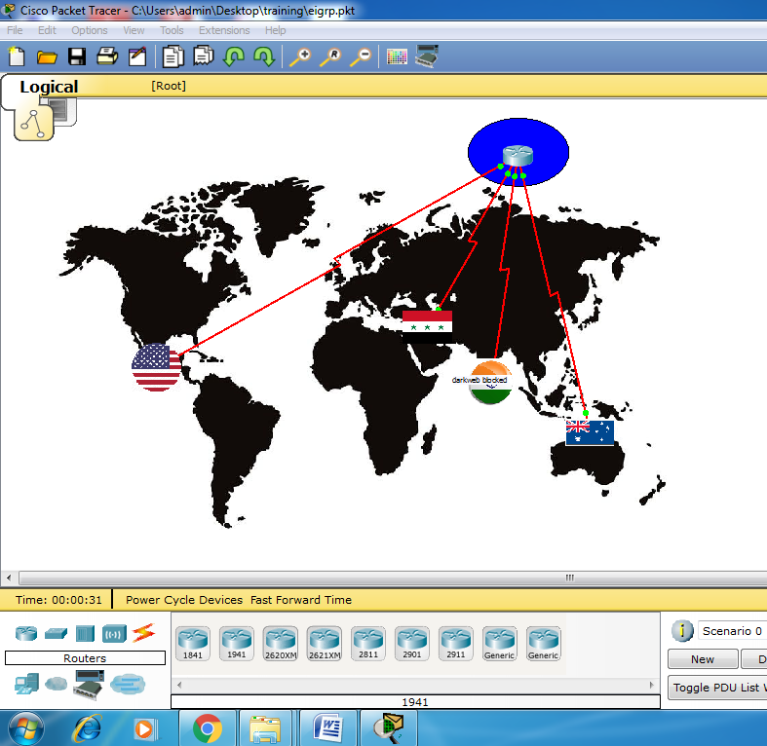

Fig1.1: overall design of four countries

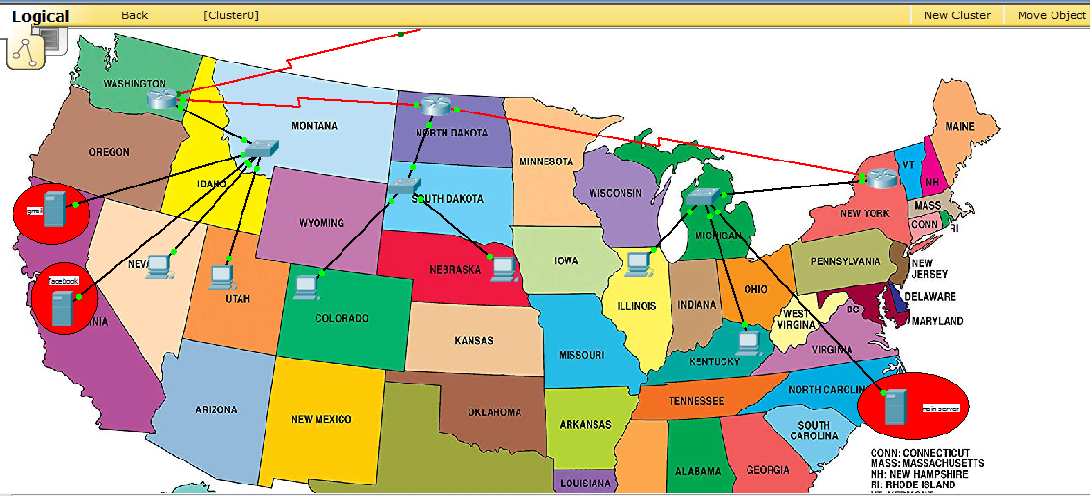

Fig:1.2: show the circuit and connection are completed

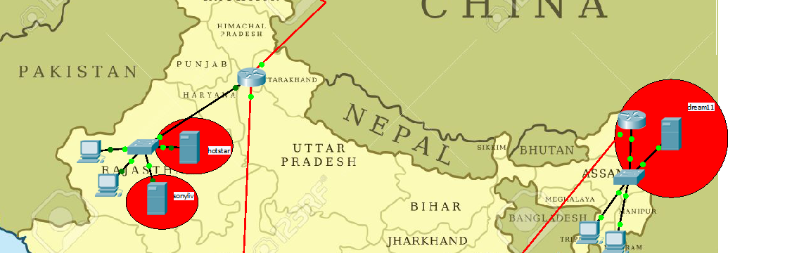

Fig:1.3: different servers and routers

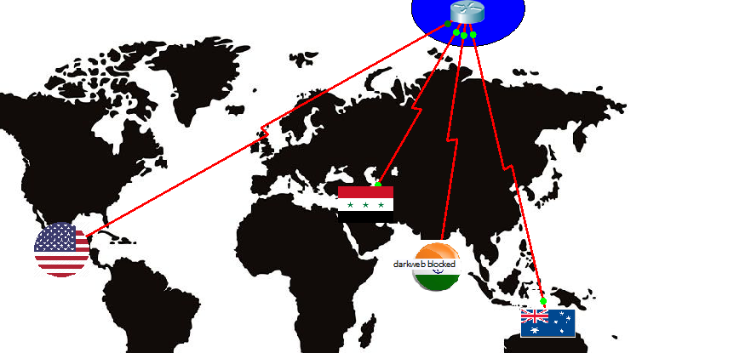

Fig: 1.4: Main router- other countries are connected with it.

All the eigrp and rip confg. Are used in it

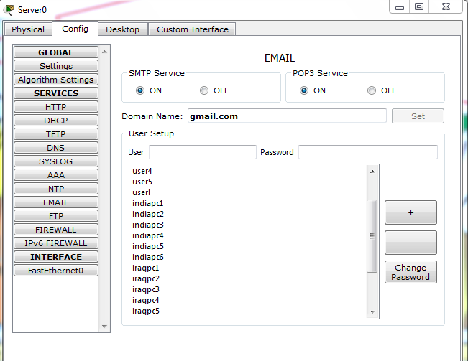

Fig1.5 username and password are added in database of Gmail

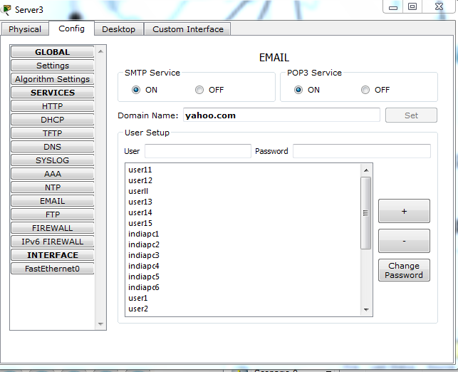

Fig 1.6 username and password are added in yahoo database

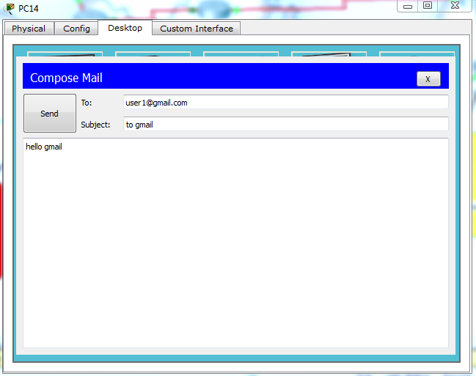

Fig 1.7 sending of email from Australia to America and using different domain system and servers

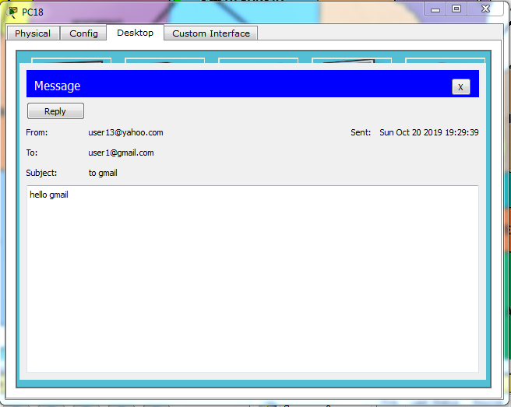

Fig 1.8 the email is received by user1 and we can reply back to him by click on reply button

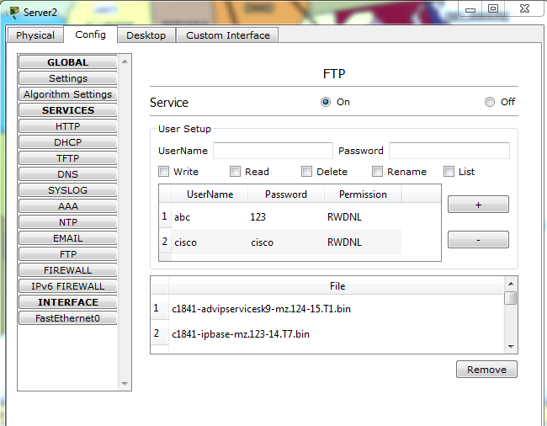

Fig 1.9 service of file transfer protocol (FTP) is used

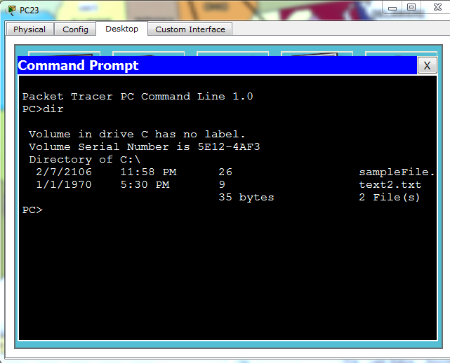

Fig 1.9 protocol ftp is used and text is create and read by the user 6

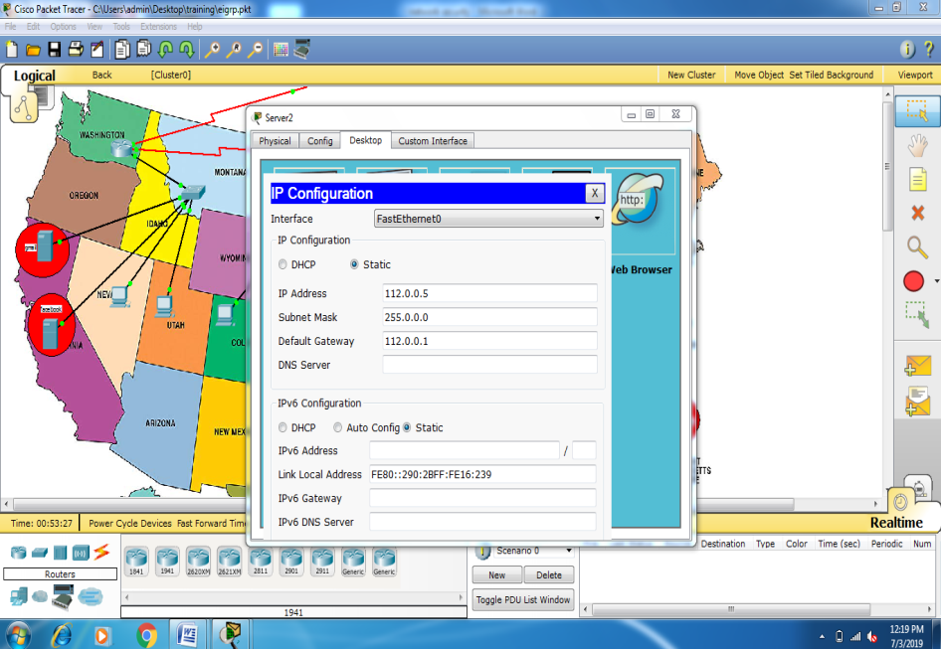

Dns server

* **Different website on web Brower using HTTPS protocol**

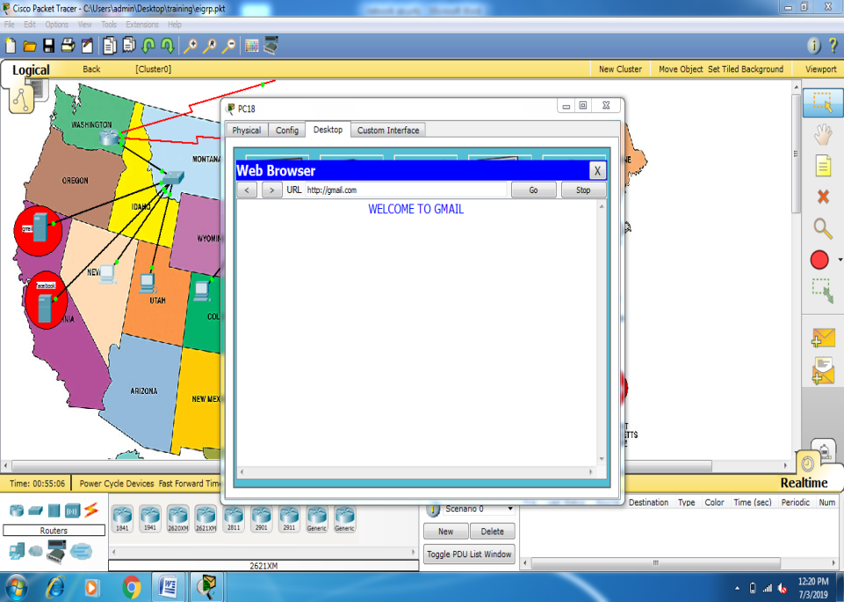

Fig 2.1 Gmail

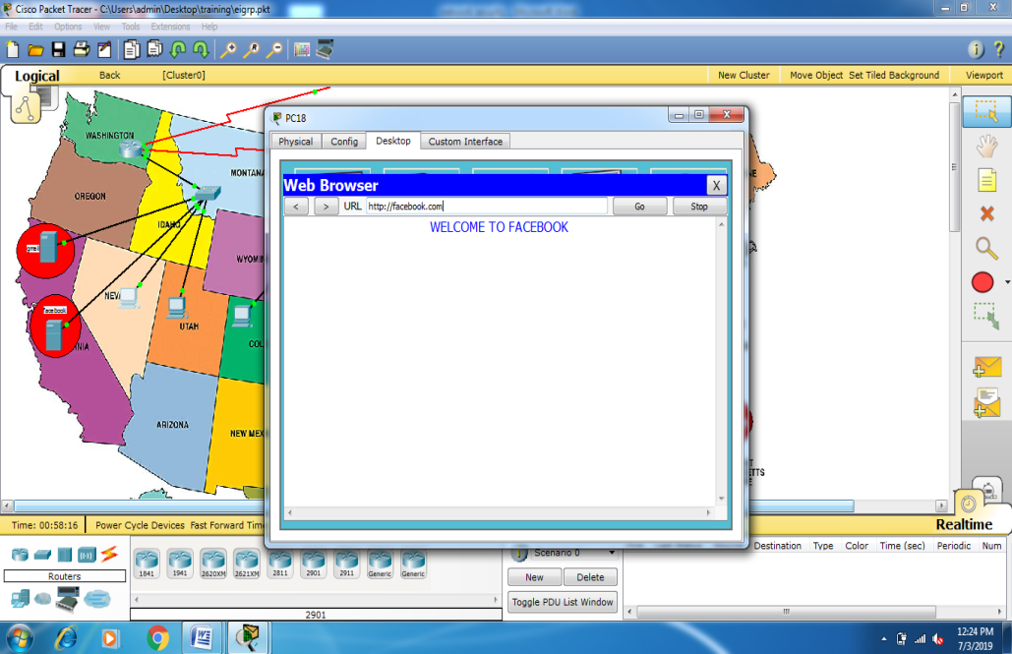

Fig. 2.2 Facebook

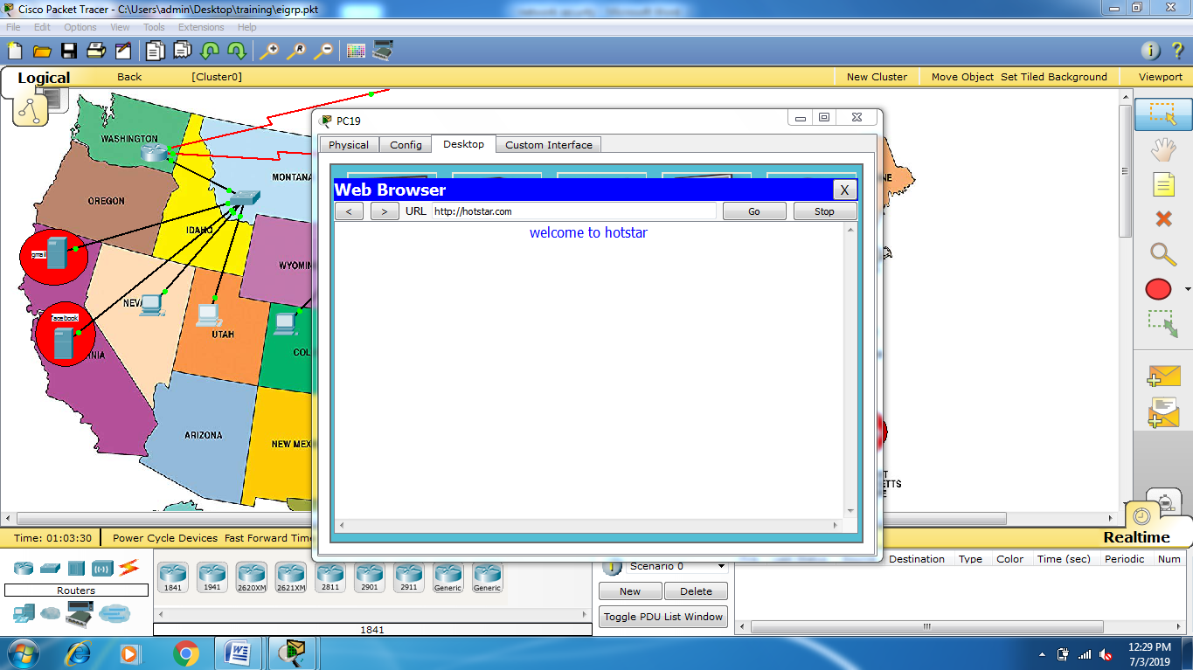

Fig. 2.3 Hotstar

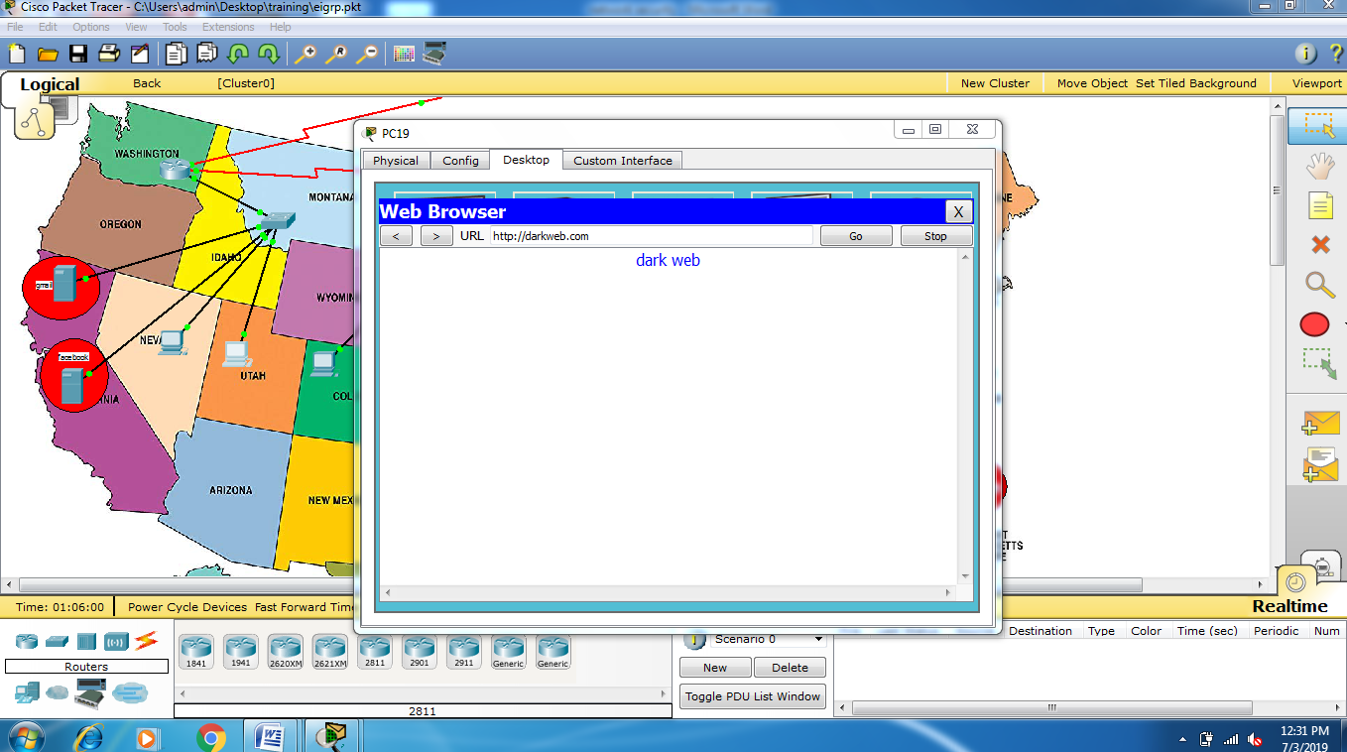

Fig 2.3 Darkweb

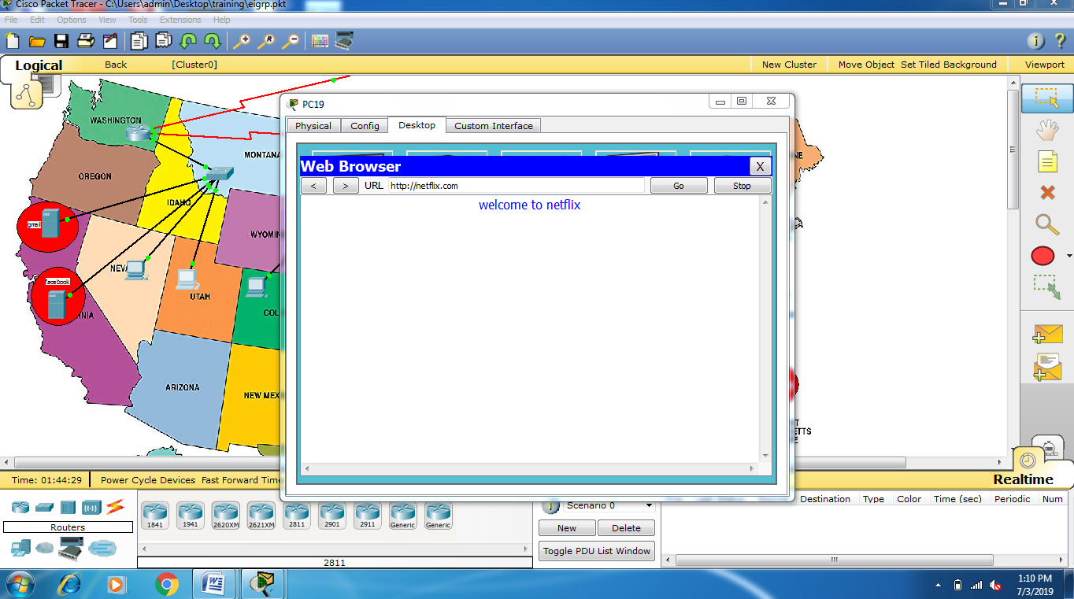

Fig. 2.4 Netflix

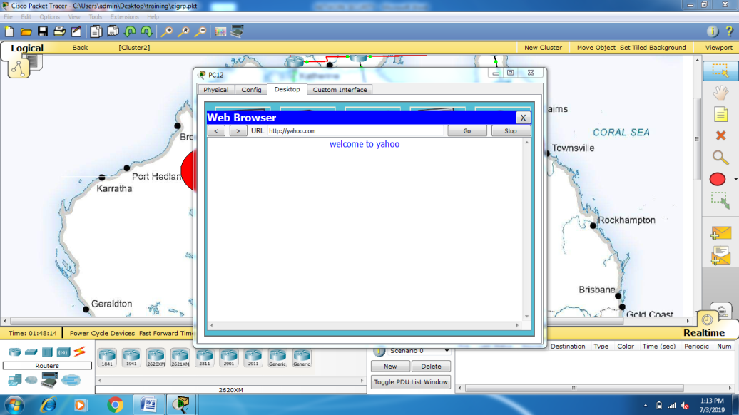

Fig. 2.5 yahoo server

**Output validation and Comparison:**

* SMTP and POP3 are used to communicate with each other through emails.
* Username and password are used to send emails for security propose and we can change the password also.
* For the security, we configure the setting and reset the password.
* Access-list is used to block the unauthorized website on the web Brower.
* Different servers are used along with Main Server which is the DNS server which is used to provide the specific name to the server’s of ip-address.

**Applications of project:**

* It is used by Google and Facebook to transfer the file and messages from one place to another.
* It is used in computer lab to provide the ip address to the system using DHCP protocol.
* We can attach number of pc with the switch using hub and router which provides the automatic ip.
* It is used in computer lab to block some unauthorized website which used not be used by the students.

**Team work:** All the team members are equally contributed on the project as per the module. Different protocols are implemented by different team mates and security module is equally done. By this project we have enhance your knowledge in networking. We have learned how to provide the security in emails and how we can connect with different countries on internet using social media. The main part which we have learnt, to provide the ip address and subnet mask to the every system using static and Dhcp protocol.

**\*\*\*\*\*\*\*\*\*\*\*\*\*\*\*\*\*\***